UNITED STATES
SECURITIES AND EXCHANGE COMMISSION
WASHINGTON, D.C. 20549

FORM 8-K

CURRENT REPORT
Pursuant to Section 13 or 15(d)
of the Securities Exchange Act of 1934
Date of Report (Date of earliest event reported): October 13, 2026

Biomea Fusion, Inc.
(Exact name of Registrant as Specified in Its Charter)

Delaware |  | 001-40335 |  | 82-2520134
(State or Other Jurisdiction  of Incorporation) |  | (Commission  File Number) |  | (IRS Employer  Identification No.)

1599 Industrial Road  San Carlos, CA |  | 94070
(Address of Principal Executive Offices) |  | (Zip Code)
Registrant’s Telephone Number, Including Area Code: (650) 980-9099
Not Applicable
(Former Name or Former Address, if Changed Since Last Report)

Check the appropriate box below if the Form 8-K filing is intended to simultaneously satisfy the filing obligation of the registrant under any of the following provisions:

☐ | Written communications pursuant to Rule 425 under the Securities Act (17 CFR 230.425)

☐ | Soliciting material pursuant to Rule 14a-12 under the Exchange Act (17 CFR 240.14a-12)

☐ | Pre-commencement communications pursuant to Rule 14d-2(b) under the Exchange Act (17 CFR 240.14d-2(b))

☐ | Pre-commencement communications pursuant to Rule 13e-4(c) under the Exchange Act (17 CFR 240.13e-4(c))
Securities registered pursuant to Section 12(b) of the Act:

Title of each class |  | Trading  Symbol(s) |  | Name of each exchange  on which registered
Common Stock, $0.0001 par value |  | BMEA |  | The Nasdaq Global Select Market
Indicate by check mark whether the registrant is an emerging growth company as defined in Rule 405 of the Securities Act of 1933 (§ 230.405 of this chapter) or Rule 12b-2 of the Securities Exchange Act of 1934 (§ 240.12b-2 of this chapter).
Emerging growth company ☒
If an emerging growth company, indicate by check mark if the registrant has elected not to use the extended transition period for complying with any new or revised financial accounting standards provided pursuant to Section 13(a) of the Exchange Act. ☐

Item 7.01 Regulation FD Disclosure
On October 13, 2026, Biomea Fusion, Inc. (the “Company”) hosted a conference call and live webcast to discuss topline data for its ongoing Phase 1 GLP-131 clinical trial for BMF-650. The Company has made available a slide presentation to accompany the call, a copy of which is furnished herewith as Exhibit 99.1 to this Current Report on Form 8-K.
The information contained in Item 7.01 of this Current Report on Form 8-K, including Exhibit 99.1 attached hereto, is being furnished and shall not be deemed to be “filed” for the purposes of Section 18 of the Securities Exchange Act of 1934, as amended (the “Exchange Act”), or otherwise subject to the liabilities of that section and shall not be incorporated by reference in any filing under the Securities Act of 1933, as amended (the “Securities Act”), or the Exchange Act, except as shall be expressly set forth by specific reference in such filing.
Item 8.01 Other Events
On October 13, 2026, the Company issued a press release titled, “Biomea Fusion Announces Phase 1 Results for BMF-650, its Investigational Next-Generation Oral Small Molecule GLP-1 Receptor Agonist.” A copy of the press release is attached to this Current Report on Form 8-K as Exhibit 99.2 and is incorporated herein by reference.
Forward-Looking Statements
Statements made or incorporated by reference in this Current Report on Form 8-K may include statements which are not historical facts and are considered forward-looking statements within the meaning of Section 27A of the Securities Act and Section 21E of the Exchange Act. These statements may be identified by words such as “aims,” “anticipates,” “believes,” “could,” “estimates,” “expects,” “forecasts,” “goal,” “intends,” “may,” “plans,” “possible,” “potential,” “seeks,” “will” and variations of these words or similar expressions that are intended to identify forward-looking statements. Any such statements in this Current Report that are not statements of historical fact, including statements regarding the clinical and therapeutic potential of the Company’s product candidates and development programs, including BMF-650 and the potential of BMF-650 as a treatment for obesity and metabolic disease, and the Company’s expectations regarding the optimal dose and target patient population; the Company’s research, development and regulatory plans; the mechanism of action of the Company’s product candidates and development programs; the progress and initiation of the Company’s ongoing and upcoming clinical trials, including its ongoing Phase 1 GLP-131 clinical trial; the anticipated availability of data from the Company’s clinical trials; the Company’s planned interactions with regulators; and the timing of such events may be deemed to be forward-looking statements. The Company intends these forward-looking statements to be covered by the safe harbor provisions for forward-looking statements contained in Section 27A of the Securities Act and Section 21E of the Exchange Act and is making this statement for purposes of complying with those safe harbor provisions.
Any forward-looking statements made or incorporated by reference in this Current Report on Form 8-K are based on the Company’s current expectations, estimates and projections only as of the date of this Current Report on Form 8-K and are subject to a number of risks and uncertainties that could cause actual results to differ materially and adversely from those set forth in or implied by such forward-looking statements, including the risk that preliminary or interim results of nonclinical studies or clinical trials may not be predictive of future or final results in connection with ongoing or future clinical trials and the risk that the Company may encounter delays in nonclinical or clinical development, patient enrollment and in the initiation, conduct and completion of the Company’s ongoing and planned clinical trials and other research and development activities. These risks concerning the Company’s business and operations are described in additional detail in its periodic filings with the U.S. Securities and Exchange Commission (the “SEC”), including its most recent periodic report filed with the SEC and subsequent filings thereafter. The Company explicitly disclaims any obligation to update any forward-looking statements except to the extent required by law.

Item 9.01. | Financial Statements and Exhibits.
(d) Exhibits

Exhibit  Number |  | Description
99.1 |  | Presentation titled “GLP-131 Phase 1 Study of BMF-650 in Otherwise Healthy Overweight or Obese Adult Participants” dated October 13, 2026, furnished herewith.
99.2 |  | Press release titled, “Biomea Fusion Announces Phase 1 Results for BMF-650, its Investigational Next-Generation Oral Small Molecule GLP-1 Receptor Agonist” on October 13, 2026.
104 |  | Cover Page Interactive Data File (embedded within the Inline XBRL document).

SIGNATURES
Pursuant to the requirements of the Securities Exchange Act of 1934, the registrant has duly caused this report to be signed on its behalf by the undersigned thereunto duly authorized.

 |  |  |  | BIOMEA FUSION, INC.
Date: October 13, 2026 |  |  |  | By: |  | /s/ Michael J.M. Hitchcock
 |  |  |  |  |  | Michael J.M. Hitchcock
Interim Chief Executive Officer, Director
(Principal Executive Officer)
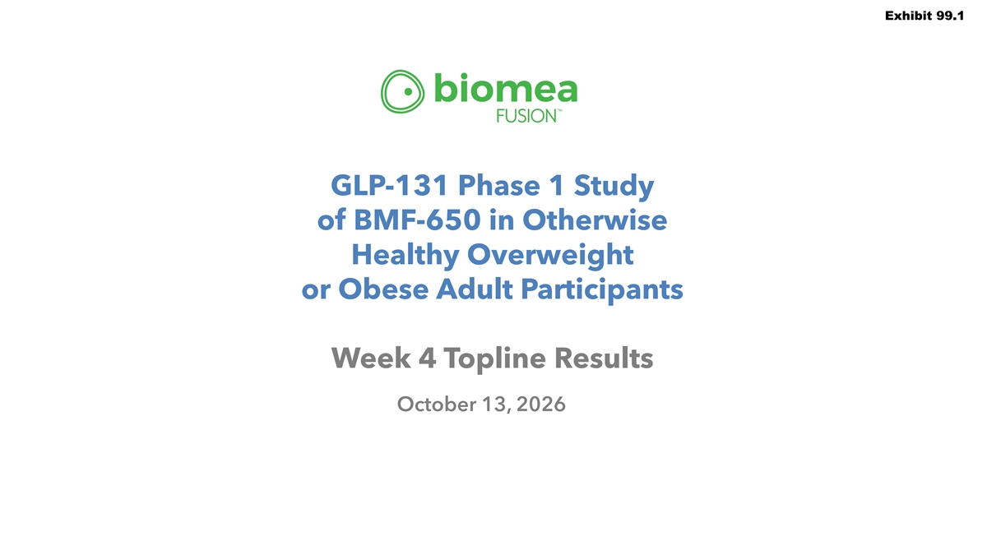
Exhibit 99.1 GLP-131 Phase 1 Study of BMF-650 in Otherwise Healthy Overweight or Obese Adult Participants Week 4 Topline Results October 13, 2026

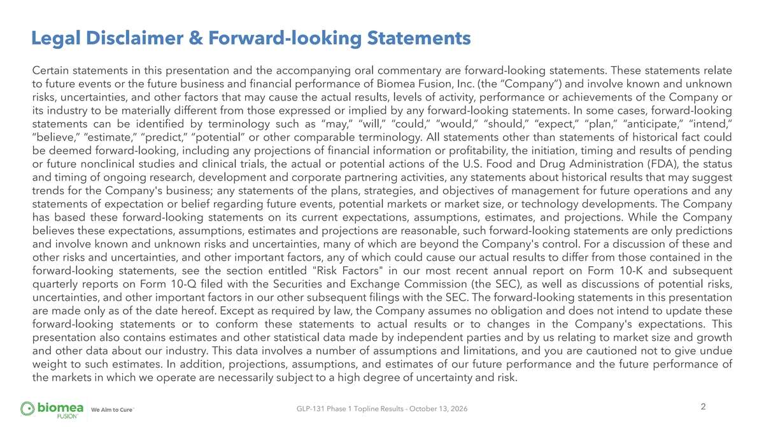
Legal Disclaimer & Forward-looking Statements Certain statements in this presentation and the accompanying oral commentary are forward-looking statements. These statements relate to future events or the future business and financial performance of Biomea Fusion, Inc. (the “Company”) and involve known and unknown risks, uncertainties, and other factors that may cause the actual results, levels of activity, performance or achievements of the Company or its industry to be materially different from those expressed or implied by any forward-looking statements. In some cases, forward-looking statements can be identified by terminology such as “may,” “will,” “could,” “would,” “should,” “expect,” “plan,” “anticipate,” “intend,” “believe,” “estimate,” “predict,” “potential” or other comparable terminology. All statements other than statements of historical fact could be deemed forward-looking, including any projections of financial information or profitability, the initiation, timing and results of pending or future nonclinical studies and clinical trials, the actual or potential actions of the U.S. Food and Drug Administration (FDA), the status and timing of ongoing research, development and corporate partnering activities, any statements about historical results that may suggest trends for the Company's business; any statements of the plans, strategies, and objectives of management for future operations and any statements of expectation or belief regarding future events, potential markets or market size, or technology developments. The Company has based these forward-looking statements on its current expectations, assumptions, estimates, and projections. While the Company believes these expectations, assumptions, estimates and projections are reasonable, such forward-looking statements are only predictions and involve known and unknown risks and uncertainties, many of which are beyond the Company's control. For a discussion of these and other risks and uncertainties, and other important factors, any of which could cause our actual results to differ from those contained in the forward-looking statements, see the section entitled Risk Factors in our most recent annual report on Form 10-K and subsequent quarterly reports on Form 10-Q filed with the Securities and Exchange Commission (the SEC), as well as discussions of potential risks, uncertainties, and other important factors in our other subsequent filings with the SEC. The forward-looking statements in this presentation are made only as of the date hereof. Except as required by law, the Company assumes no obligation and does not intend to update these forward-looking statements or to conform these statements to actual results or to changes in the Company's expectations. This presentation also contains estimates and other statistical data made by independent parties and by us relating to market size and growth and other data about our industry. This data involves a number of assumptions and limitations, and you are cautioned not to give undue weight to such estimates. In addition, projections, assumptions, and estimates of our future performance and the future performance of the markets in which we operate are necessarily subject to a high degree of uncertainty and risk. 2 GLP-131 Phase 1 Topline Results - October 13, 2026

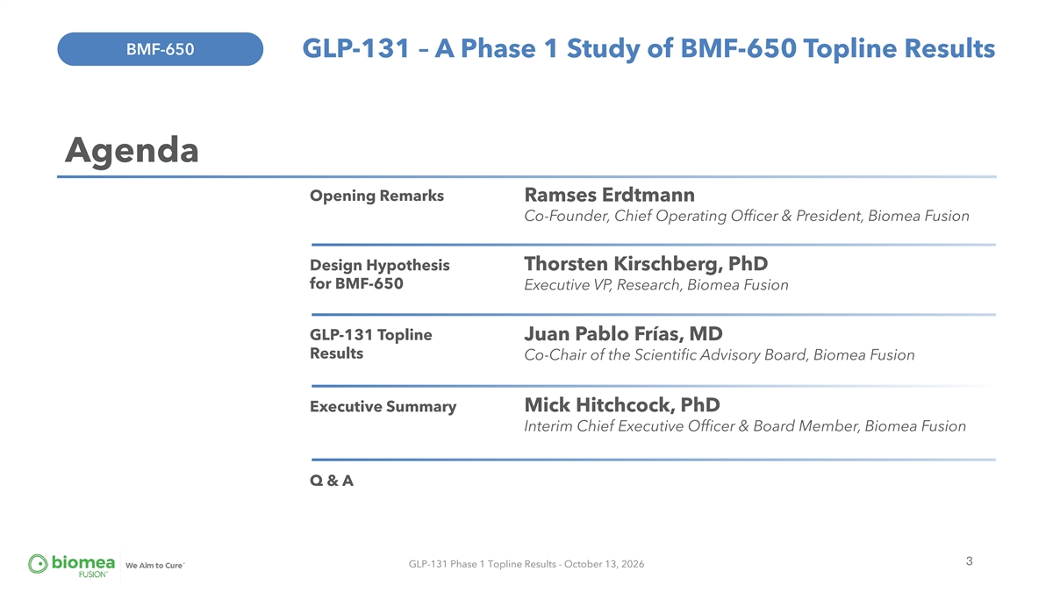
BMF-650 GLP-131 – A Phase 1 Study of BMF-650 Topline Results Agenda Opening Remarks Ramses Erdtmann Co-Founder, Chief Operating Officer & President, Biomea Fusion Design Hypothesis Thorsten Kirschberg, PhD for BMF-650 Executive VP, Research, Biomea Fusion GLP-131 Topline Juan Pablo Frías, MD Results Co-Chair of the Scientific Advisory Board, Biomea Fusion Executive Summary Mick Hitchcock, PhD Interim Chief Executive Officer & Board Member, Biomea Fusion Q & A 3 GLP-131 Phase 1 Topline Results - October 13, 2026

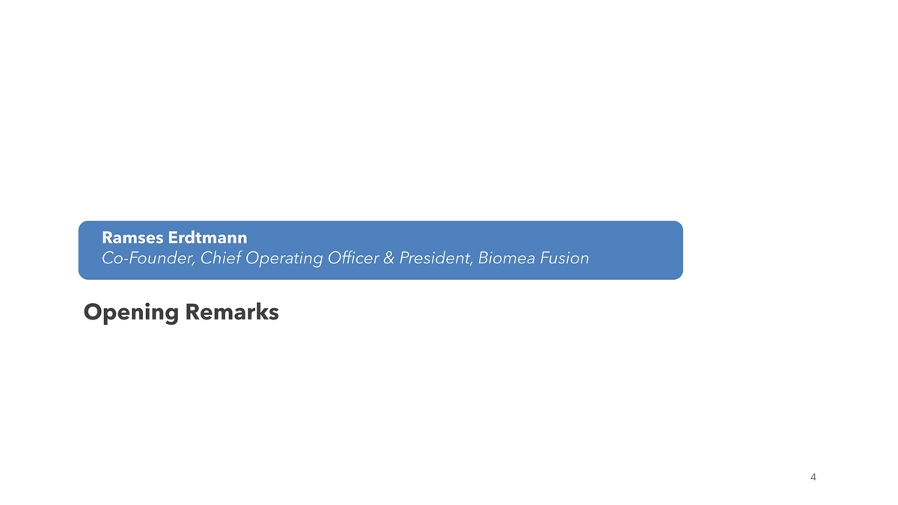
Ramses Erdtmann Co-Founder, Chief Operating Officer & President, Biomea Fusion Opening Remarks 4

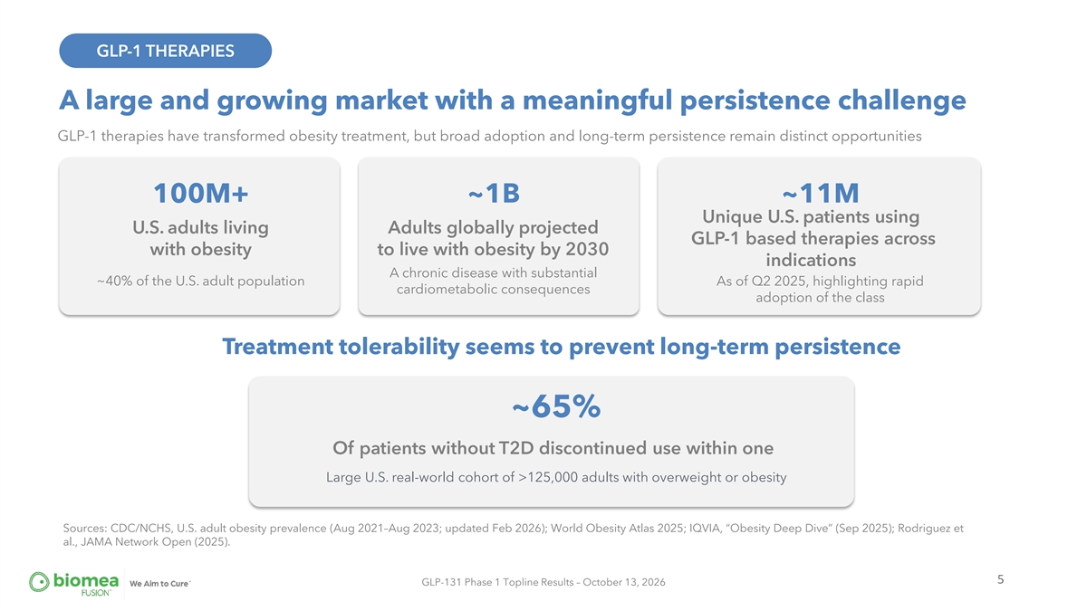
GLP-1 THERAPIES A large and growing market with a meaningful persistence challenge GLP-1 therapies have transformed obesity treatment, but broad adoption and long-term persistence remain distinct opportunities 100M+ ~1B ~11M Unique U.S. patients using U.S. adults living Adults globally projected GLP-1 based therapies across with obesity to live with obesity by 2030 indications A chronic disease with substantial ~40% of the U.S. adult population As of Q2 2025, highlighting rapid cardiometabolic consequences adoption of the class Treatment tolerability seems to prevent long-term persistence ~65% Of patients without T2D discontinued use within one Large U.S. real-world cohort of >125,000 adults with overweight or obesity Sources: CDC/NCHS, U.S. adult obesity prevalence (Aug 2021–Aug 2023; updated Feb 2026); World Obesity Atlas 2025; IQVIA, “Obesity Deep Dive” (Sep 2025); Rodriguez et al., JAMA Network Open (2025). 5 GLP-131 Phase 1 Topline Results – October 13, 2026

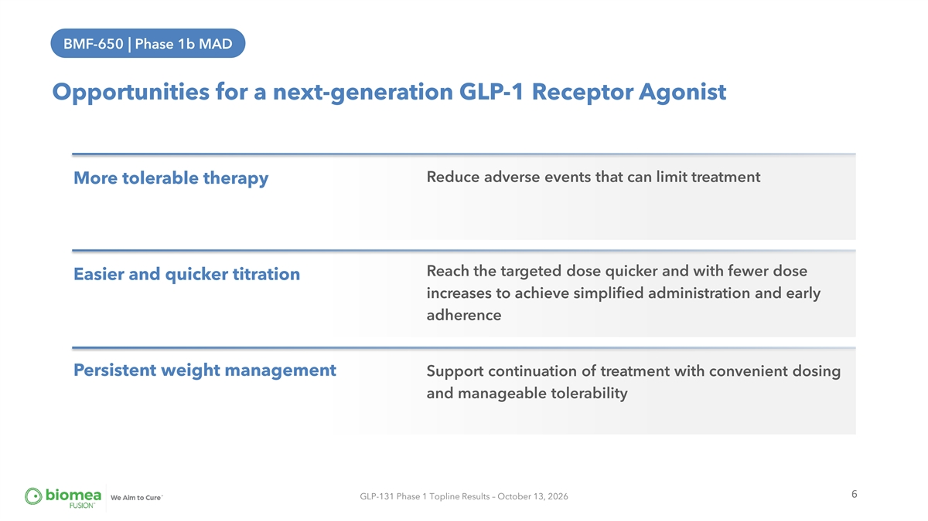
BMF-650 | Phase 1b MAD Opportunities for a next-generation GLP-1 Receptor Agonist Reduce adverse events that can limit treatment More tolerable therapy Reach the targeted dose quicker and with fewer dose Easier and quicker titration increases to achieve simplified administration and early adherence Persistent weight management Support continuation of treatment with convenient dosing and manageable tolerability 6 GLP-131 Phase 1 Topline Results – October 13, 2026

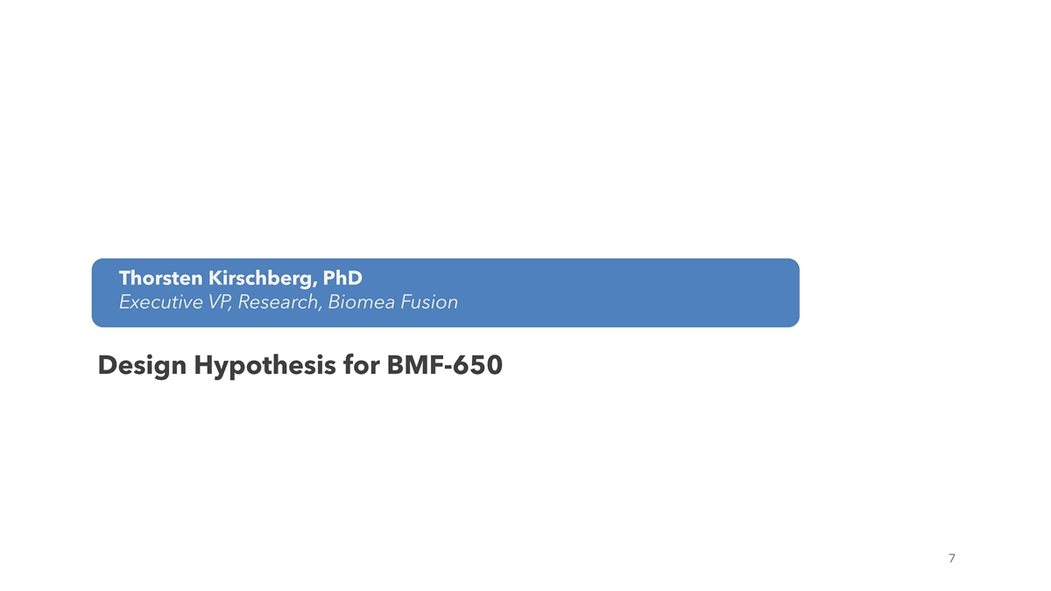
Thorsten Kirschberg, PhD Executive VP, Research, Biomea Fusion Design Hypothesis for BMF-650 7

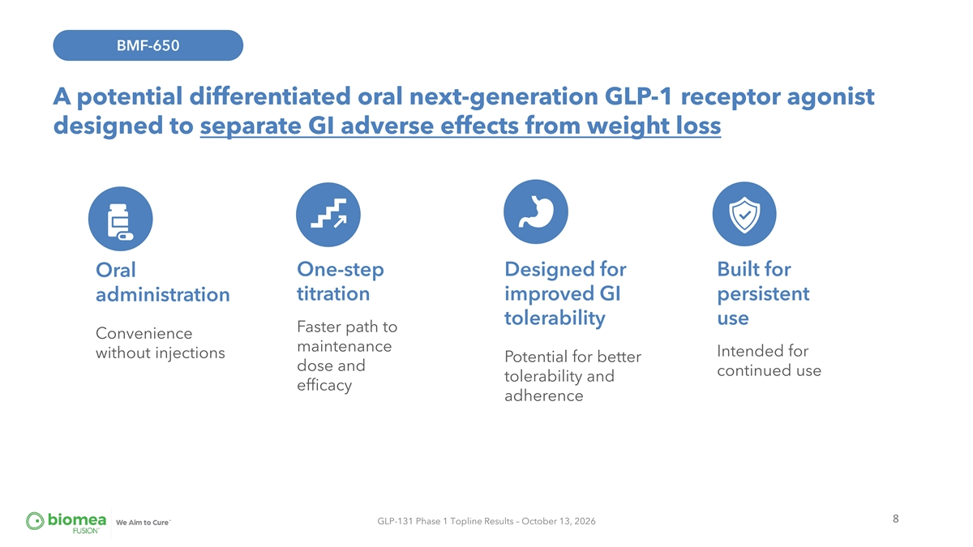
BMF-650 A potential differentiated oral next-generation GLP-1 receptor agonist designed to separate GI adverse effects from weight loss One-step Designed for Built for Oral titration improved GI persistent administration tolerability use Faster path to Convenience maintenance Intended for without injections Potential for better dose and continued use tolerability and efficacy adherence 8 GLP-131 Phase 1 Topline Results – October 13, 2026

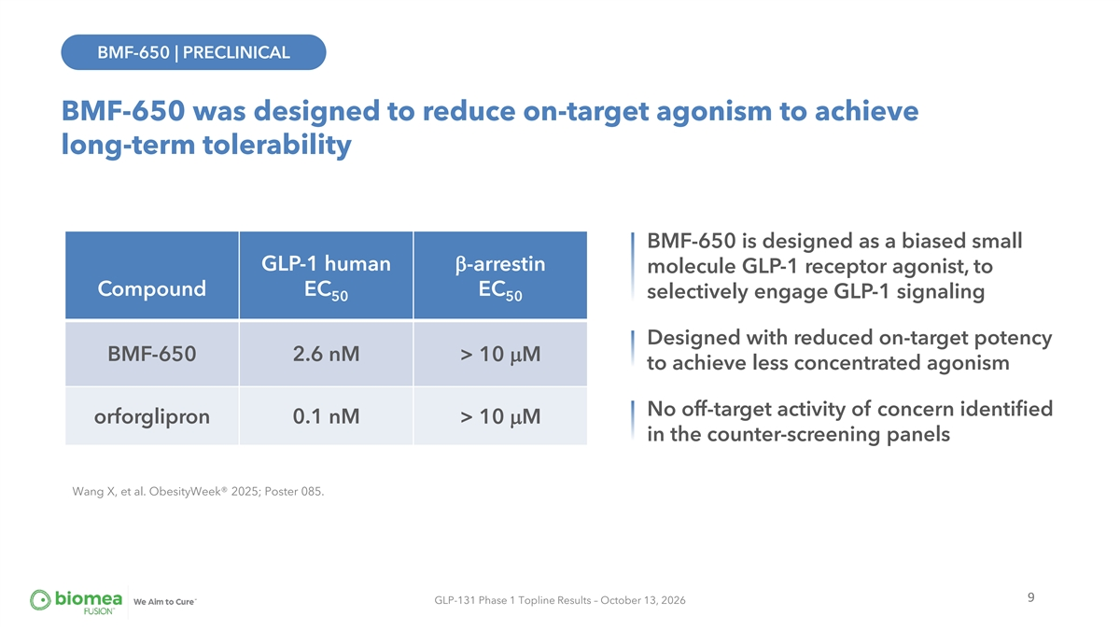
BMF-650 | PRECLINICAL BMF-650 was designed to reduce on-target agonism to achieve long-term tolerability BMF-650 is designed as a biased small GLP-1 human β-arrestin molecule GLP-1 receptor agonist, to Compound EC EC selectively engage GLP-1 signaling 50 50 Designed with reduced on-target potency BMF-650 2.6 nM > 10 µM to achieve less concentrated agonism No off-target activity of concern identified orforglipron 0.1 nM > 10 µM in the counter-screening panels Wang X, et al. ObesityWeek® 2025; Poster 085. 9 GLP-131 Phase 1 Topline Results – October 13, 2026

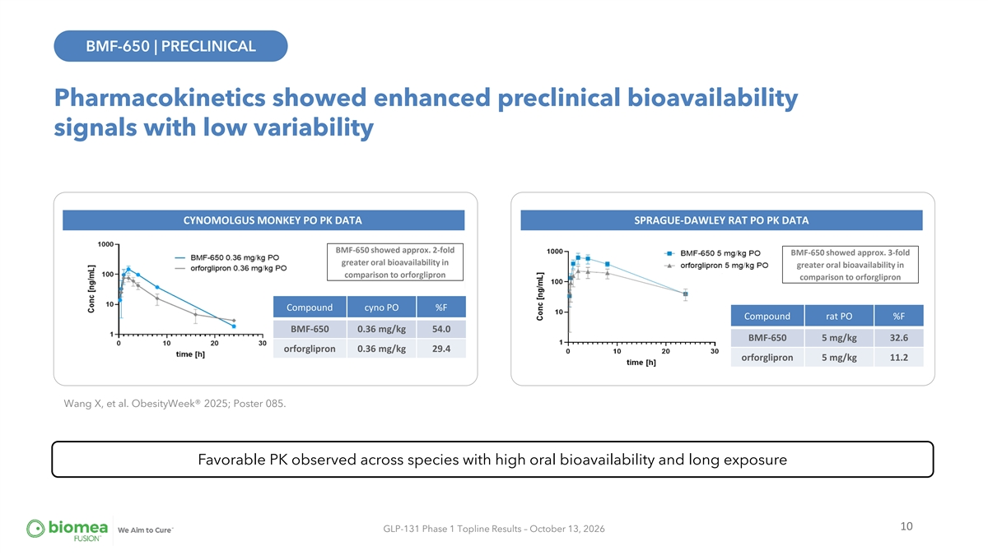
BMF-650 | PRECLINICAL BMF-650 | PRECLINICAL Pharmacokinetics showed enhanced preclinical bioavailability signals with low variability CYNOMOLGUS MONKEY PO PK DATA SPRAGUE-DAWLEY RAT PO PK DATA BMF-650 showed approx. 2-fold BMF-650 showed approx. 3-fold greater oral bioavailability in greater oral bioavailability in comparison to orforglipron comparison to orforglipron Compound cyno PO %F Compound rat PO %F BMF-650 0.36 mg/kg 54.0 BMF-650 5 mg/kg 32.6 orforglipron 0.36 mg/kg 29.4 orforglipron 5 mg/kg 11.2 Wang X, et al. ObesityWeek® 2025; Poster 085. Favorable PK observed across species with high oral bioavailability and long exposure 10 GLP-131 Phase 1 Topline Results – October 13, 2026

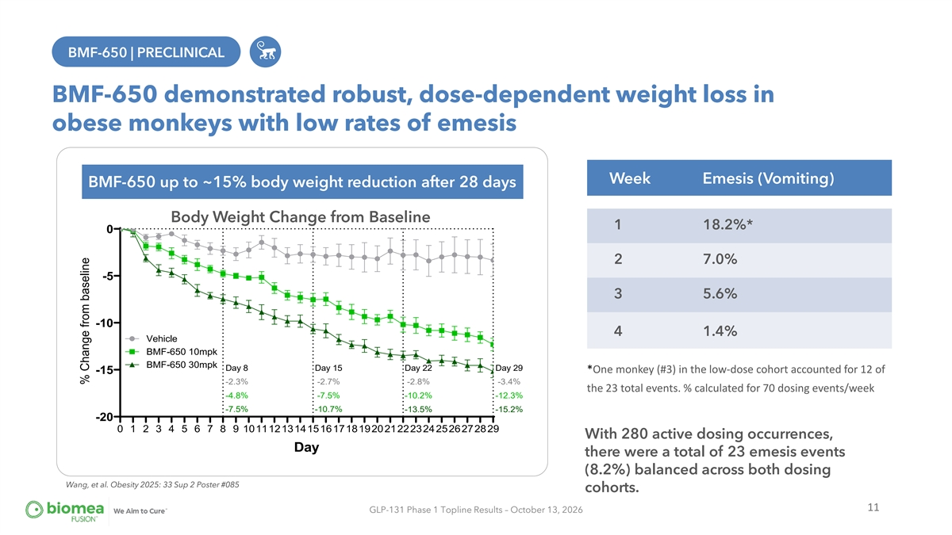
BMF-650 | PRECLINICAL BMF-650 | PRECLINICAL BMF-650 demonstrated robust, dose-dependent weight loss in obese monkeys with low rates of emesis Week Emesis (Vomiting) BMF-650 up to ~15% body weight reduction after 28 days Body Weight Change from Baseline 1 18.2%* 0 2 7.0% -5 3 5.6% -10 4 1.4% Vehicle BMF-650 10mpk BMF-650 30mpk Day 8 Day 15 Day 22 Day 29 *One monkey (#3) in the low-dose cohort accounted for 12 of -15 -2.3% -2.7% -2.8% -3.4% the 23 total events. % calculated for 70 dosing events/week -4.8% -7.5% -10.2% -12.3% -7.5% -10.7% -13.5% -15.2% -20 0 1 2 3 4 5 6 7 8 9 1011121314151617181920212223242526272829 With 280 active dosing occurrences, Day there were a total of 23 emesis events (8.2%) balanced across both dosing Wang, et al. Obesity 2025: 33 Sup 2 Poster #085 cohorts. 11 GLP-131 Phase 1 Topline Results – October 13, 2026 % Change from baseline

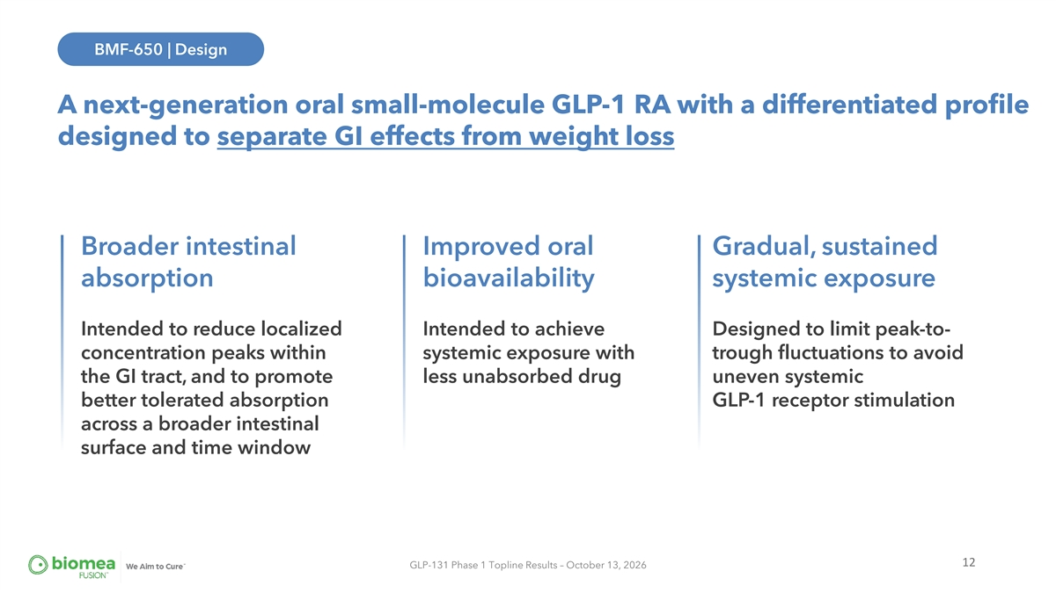
BMF-650 | Design A next-generation oral small-molecule GLP-1 RA with a differentiated profile designed to separate GI effects from weight loss Broader intestinal Improved oral Gradual, sustained absorption bioavailability systemic exposure Intended to reduce localized Intended to achieve Designed to limit peak-to- concentration peaks within systemic exposure with trough fluctuations to avoid the GI tract, and to promote less unabsorbed drug uneven systemic better tolerated absorption GLP-1 receptor stimulation across a broader intestinal surface and time window 12 GLP-131 Phase 1 Topline Results – October 13, 2026

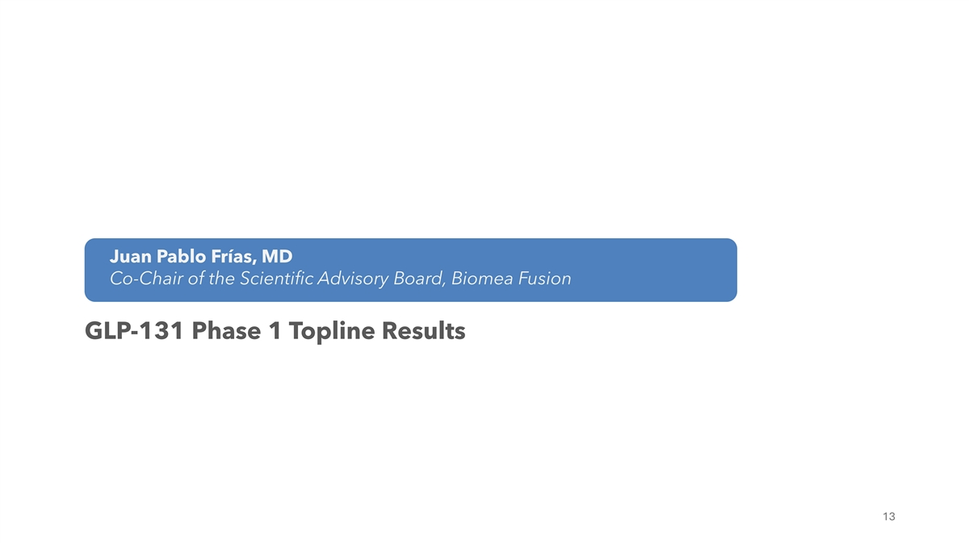
Juan Pablo Frías, MD Co-Chair of the Scientific Advisory Board, Biomea Fusion GLP-131 Phase 1 Topline Results Dr. Juan Pablo Frias Chief Medical Officer of Biomea Fusion 13

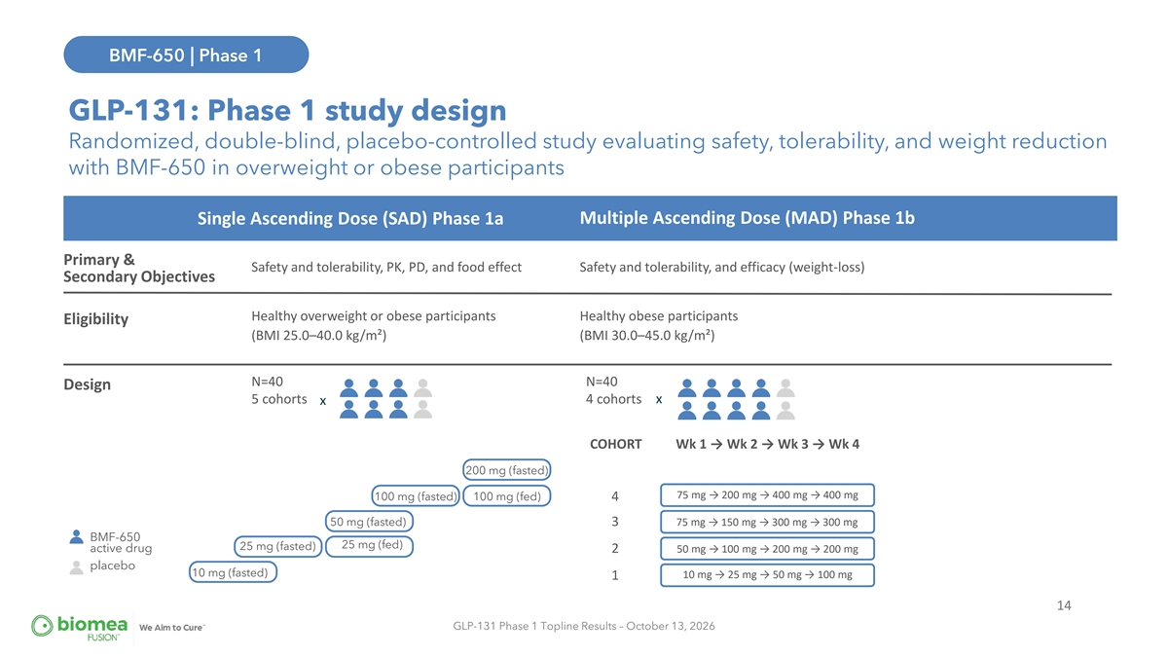
BMF-650 | Phase 1 BMF-650 | GLP-131 GLP-131: Phase 1 study design Randomized, double-blind, placebo-controlled study evaluating safety, tolerability, and weight reduction with BMF-650 in overweight or obese participants Multiple Ascending Dose (MAD) Phase 1b Single Ascending Dose (SAD) Phase 1a Primary & Safety and tolerability, PK, PD, and food effect Safety and tolerability, and efficacy (weight-loss) Secondary Objectives Healthy overweight or obese participants Healthy obese participants Eligibility (BMI 25.0–40.0 kg/m²) (BMI 30.0–45.0 kg/m²) N=40 N=40 Design 5 cohorts 4 cohorts x x COHORT Wk 1 → Wk 2 → Wk 3 → Wk 4 200 mg (fasted) 75 mg → 200 mg → 400 mg → 400 mg 100 mg (fasted) 100 mg (fed) 4 50 mg (fasted) 3 75 mg → 150 mg → 300 mg → 300 mg BMF-650 25 mg (fed) 25 mg (fasted) active drug 50 mg → 100 mg → 200 mg → 200 mg 2 placebo 10 mg (fasted) 10 mg → 25 mg → 50 mg → 100 mg 1 14 GLP-131 Phase 1 Topline Results – October 13, 2026

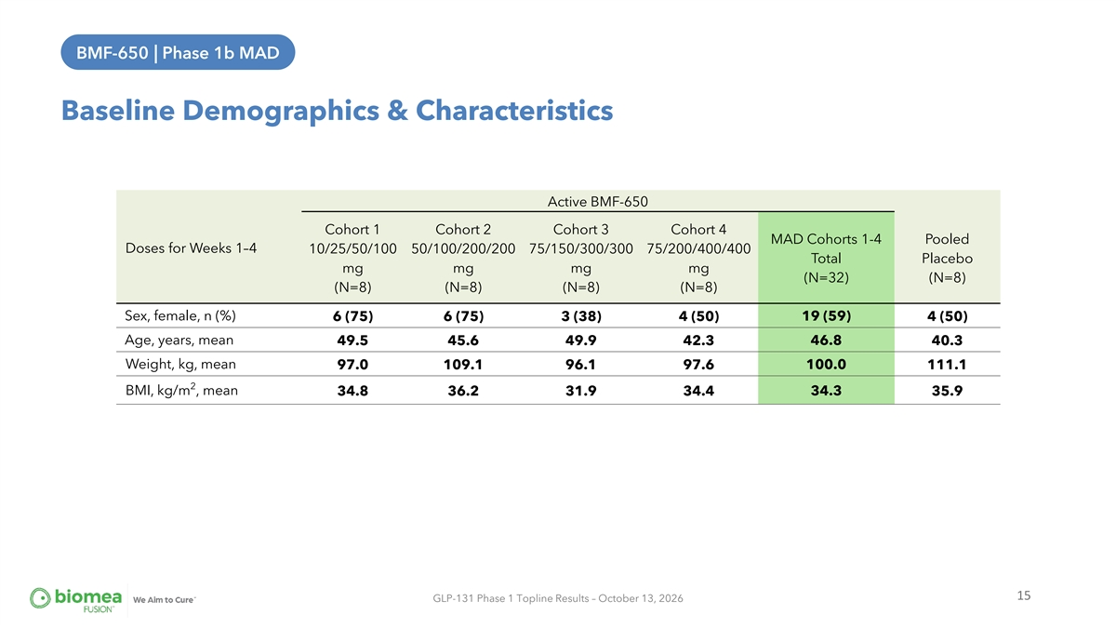
BMF-650 | Phase 1b MAD BMF-650 | Phase 1B MAD Baseline Demographics & Characteristics Active BMF-650 Cohort 1 Cohort 2 Cohort 3 Cohort 4 MAD Cohorts 1-4 Pooled Doses for Weeks 1–4 10/25/50/100 50/100/200/200 75/150/300/300 75/200/400/400 Total Placebo mg mg mg mg (N=32) (N=8) (N=8) (N=8) (N=8) (N=8) Sex, female, n (%) 6 (75) 6 (75) 3 (38) 4 (50) 19 (59) 4 (50) Age, years, mean 49.5 45.6 49.9 42.3 46.8 40.3 Weight, kg, mean 97.0 109.1 96.1 97.6 100.0 111.1 2 BMI, kg/m , mean 34.8 36.2 31.9 34.4 34.3 35.9 15 GLP-131 Phase 1 Topline Results – October 13, 2026

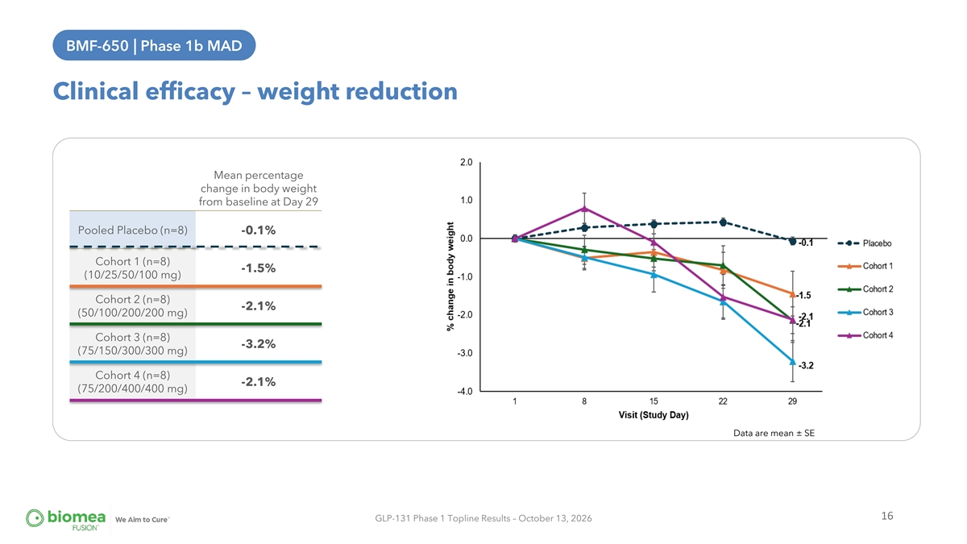
BMF-650 | Phase 1b MAD BMF-650 | Phase 1B MAD Clinical efficacy – weight reduction Mean percentage change in body weight from baseline at Day 29 Pooled Placebo (n=8) -0.1% Cohort 1 (n=8) -1.5% (10/25/50/100 mg) Cohort 2 (n=8) -2.1% (50/100/200/200 mg) Cohort 3 (n=8) -3.2% (75/150/300/300 mg) Cohort 4 (n=8) -2.1% (75/200/400/400 mg) Data are mean ± SE 16 GLP-131 Phase 1 Topline Results – October 13, 2026

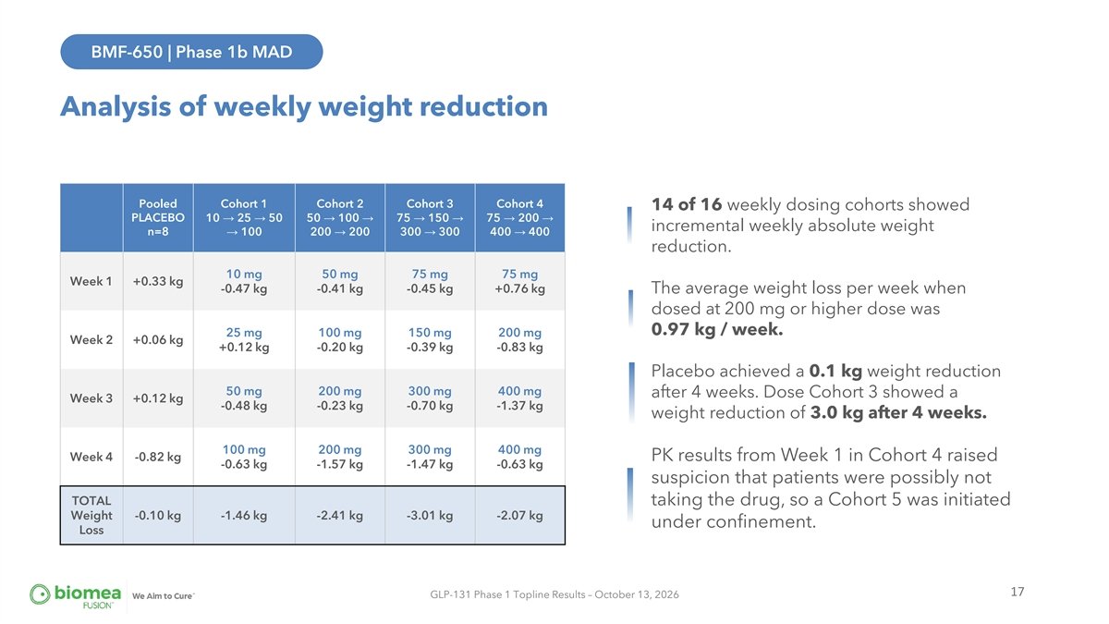
BMF-650 | Phase 1b MAD Analysis of weekly weight reduction Pooled Cohort 1 Cohort 2 Cohort 3 Cohort 4 14 of 16 weekly dosing cohorts showed PLACEBO 10 → 25 → 50 50 → 100 → 75 → 150 → 75 → 200 → incremental weekly absolute weight n=8→ 100 200 → 200 300 → 300 400 → 400 reduction. 10 mg 50 mg 75 mg 75 mg Week 1 +0.33 kg -0.47 kg -0.41 kg -0.45 kg +0.76 kg The average weight loss per week when dosed at 200 mg or higher dose was 0.97 kg / week. 25 mg 100 mg 150 mg 200 mg Week 2 +0.06 kg +0.12 kg -0.20 kg -0.39 kg -0.83 kg Placebo achieved a 0.1 kg weight reduction 50 mg 200 mg 300 mg 400 mg after 4 weeks. Dose Cohort 3 showed a Week 3 +0.12 kg -0.48 kg -0.23 kg -0.70 kg -1.37 kg weight reduction of 3.0 kg after 4 weeks. 100 mg 200 mg 300 mg 400 mg Week 4 -0.82 kg PK results from Week 1 in Cohort 4 raised -0.63 kg -1.57 kg -1.47 kg -0.63 kg suspicion that patients were possibly not TOTAL taking the drug, so a Cohort 5 was initiated Weight -0.10 kg -1.46 kg -2.41 kg -3.01 kg -2.07 kg under confinement. Loss 17 GLP-131 Phase 1 Topline Results – October 13, 2026

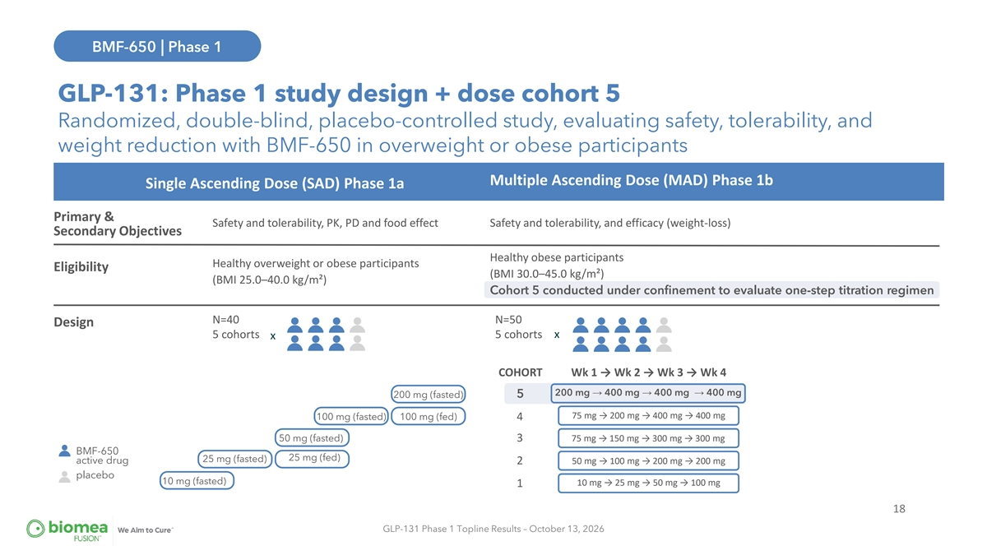
BMF-650 | Phase 1 BMF-650 | GLP-131 GLP-131: Phase 1 study design + dose cohort 5 Randomized, double-blind, placebo-controlled study, evaluating safety, tolerability, and weight reduction with BMF-650 in overweight or obese participants Multiple Ascending Dose (MAD) Phase 1b Single Ascending Dose (SAD) Phase 1a Primary & Safety and tolerability, PK, PD and food effect Safety and tolerability, and efficacy (weight-loss) Secondary Objectives Healthy obese participants Healthy overweight or obese participants Eligibility (BMI 30.0–45.0 kg/m²) (BMI 25.0–40.0 kg/m²) Cohort 5 conducted under confinement to evaluate one-step titration regimen N=40 N=50 Design 5 cohorts 5 cohorts x x COHORT Wk 1 → Wk 2 → Wk 3 → Wk 4 200 mg → 400 mg → 400 mg → 400 mg 200 mg (fasted) 5 75 mg → 200 mg → 400 mg → 400 mg 100 mg (fasted) 100 mg (fed) 4 50 mg (fasted) 3 75 mg → 150 mg → 300 mg → 300 mg BMF-650 25 mg (fed) 25 mg (fasted) active drug 2 50 mg → 100 mg → 200 mg → 200 mg placebo 10 mg (fasted) 10 mg → 25 mg → 50 mg → 100 mg 1 18 GLP-131 Phase 1 Topline Results – October 13, 2026

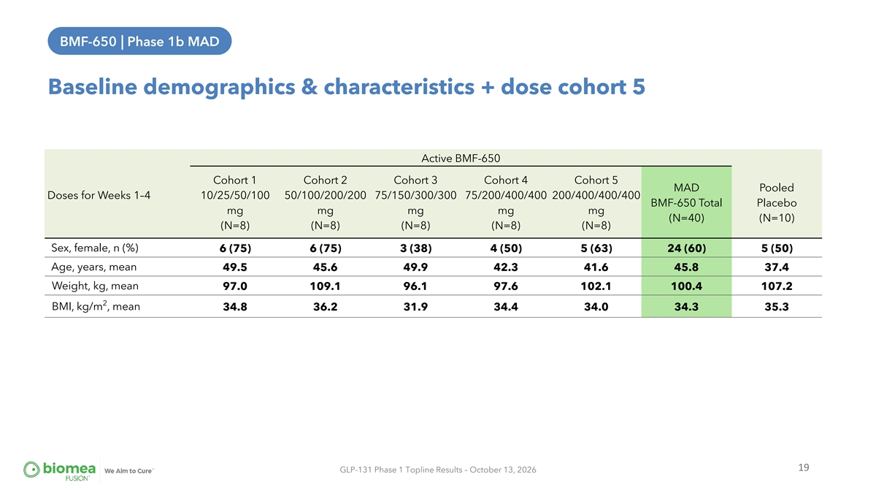
BMF-650 | Phase 1b MAD BMF-650 | Phase 1B MAD Baseline demographics & characteristics + dose cohort 5 Active BMF-650 Cohort 1 Cohort 2 Cohort 3 Cohort 4 Cohort 5 MAD Pooled Doses for Weeks 1–4 10/25/50/100 50/100/200/200 75/150/300/300 75/200/400/400 200/400/400/400 BMF-650 Total Placebo mg mg mg mg mg (N=40) (N=10) (N=8) (N=8) (N=8) (N=8) (N=8) Sex, female, n (%) 6 (75) 6 (75) 3 (38) 4 (50) 5 (63) 24 (60) 5 (50) Age, years, mean 49.5 45.6 49.9 42.3 41.6 45.8 37.4 Weight, kg, mean 97.0 109.1 96.1 97.6 102.1 100.4 107.2 2 BMI, kg/m , mean 34.8 36.2 31.9 34.4 34.0 34.3 35.3 19 GLP-131 Phase 1 Topline Results – October 13, 2026

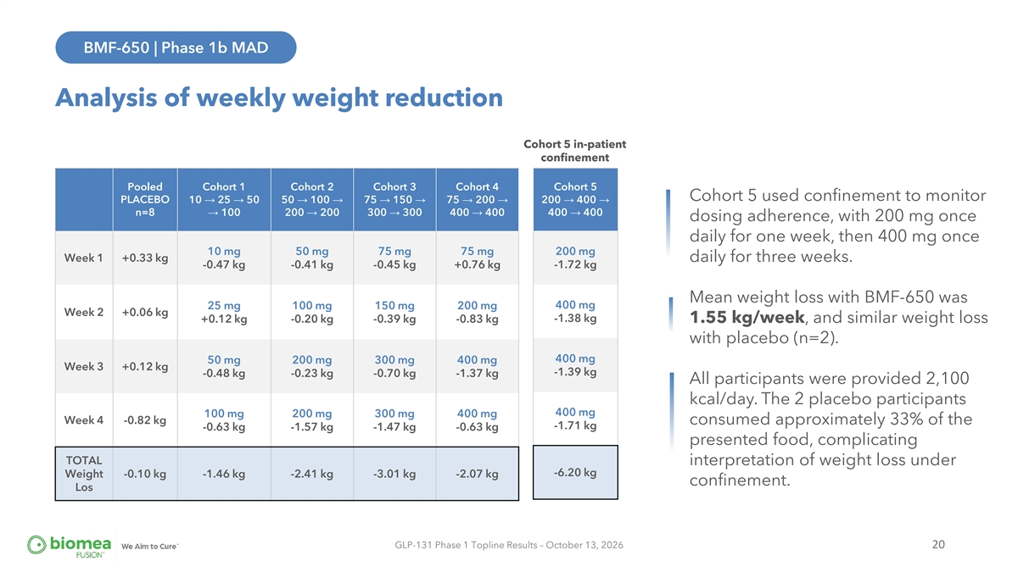
BMF-650 | Phase 1b MAD Analysis of weekly weight reduction Cohort 5 in-patient confinement Pooled Cohort 1 Cohort 2 Cohort 3 Cohort 4 Cohort 5 Cohort 5 used confinement to monitor PLACEBO 10 → 25 → 50 50 → 100 → 75 → 150 → 75 → 200 → 200 → 400 → n=8→ 100 200 → 200 300 → 300 400 → 400 400 → 400 dosing adherence, with 200 mg once daily for one week, then 400 mg once 10 mg 50 mg 75 mg 75 mg 200 mg Week 1 +0.33 kg daily for three weeks. -0.47 kg -0.41 kg -0.45 kg +0.76 kg -1.72 kg Mean weight loss with BMF-650 was 400 mg 25 mg 100 mg 150 mg 200 mg Week 2 +0.06 kg -1.38 kg +0.12 kg -0.20 kg -0.39 kg -0.83 kg 1.55 kg/week, and similar weight loss with placebo (n=2). 400 mg 50 mg 200 mg 300 mg 400 mg Week 3 +0.12 kg -1.39 kg -0.48 kg -0.23 kg -0.70 kg -1.37 kg All participants were provided 2,100 kcal/day. The 2 placebo participants 400 mg 100 mg 200 mg 300 mg 400 mg Week 4 -0.82 kg consumed approximately 33% of the -1.71 kg -0.63 kg -1.57 kg -1.47 kg -0.63 kg presented food, complicating TOTAL interpretation of weight loss under -6.20 kg Weight -0.10 kg -1.46 kg -2.41 kg -3.01 kg -2.07 kg confinement. Los GLP-131 Phase 1 Topline Results – October 13, 2026 20

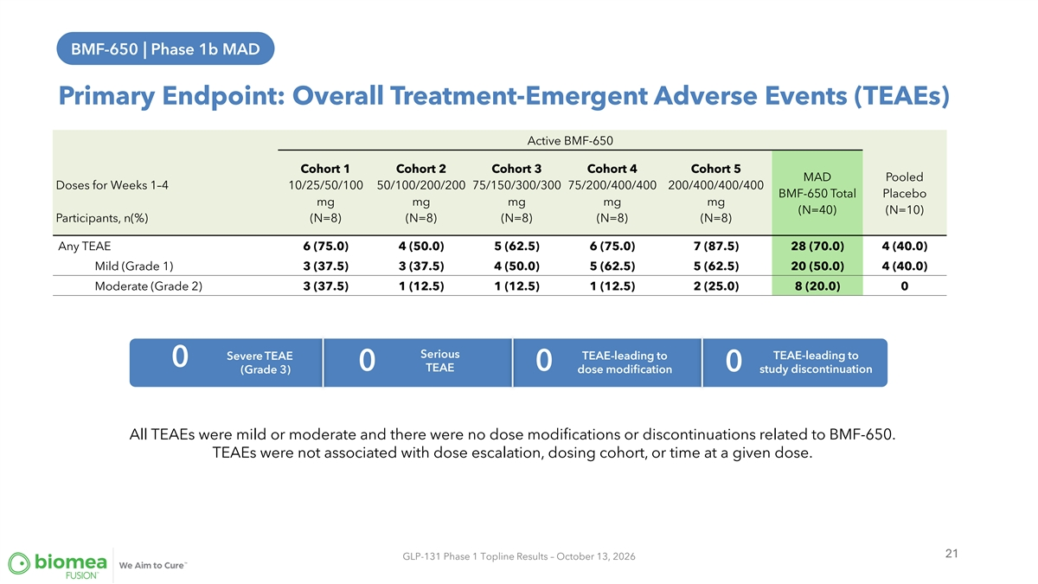
BMF-650 | Phase 1b MAD Primary Endpoint: Overall Treatment-Emergent Adverse Events (TEAEs) Active BMF-650 Cohort 1 Cohort 2 Cohort 3 Cohort 4 Cohort 5 MAD Pooled Doses for Weeks 1–4 10/25/50/100 50/100/200/200 75/150/300/300 75/200/400/400 200/400/400/400 BMF-650 Total Placebo mg mg mg mg mg (N=40) (N=10) Participants, n(%) (N=8) (N=8) (N=8) (N=8) (N=8) Any TEAE 6 (75.0) 4 (50.0) 5 (62.5) 6 (75.0) 7 (87.5) 28 (70.0) 4 (40.0) Mild (Grade 1) 3 (37.5) 3 (37.5) 4 (50.0) 5 (62.5) 5 (62.5) 20 (50.0) 4 (40.0) Moderate (Grade 2) 3 (37.5) 1 (12.5) 1 (12.5) 1 (12.5) 2 (25.0) 8 (20.0) 0 Serious TEAE-leading to Severe TEAE TEAE-leading to 0 0 0 0 TEAE (Grade 3) dose modification study discontinuation All TEAEs were mild or moderate and there were no dose modifications or discontinuations related to BMF-650. TEAEs were not associated with dose escalation, dosing cohort, or time at a given dose. 21 GLP-131 Phase 1 Topline Results – October 13, 2026

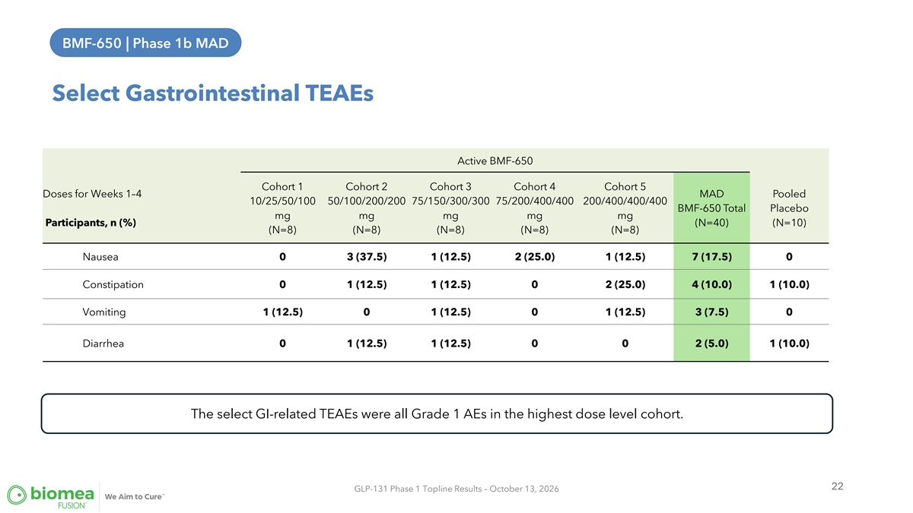
BMF-650 | Phase 1b MAD BMF-650 | Phase 1B MAD Select Gastrointestinal TEAEs Active BMF-650 Cohort 1 Cohort 2 Cohort 3 Cohort 4 Cohort 5 Doses for Weeks 1–4 MAD Pooled 10/25/50/100 50/100/200/200 75/150/300/300 75/200/400/400 200/400/400/400 BMF-650 Total Placebo mg mg mg mg mg Participants, n (%) (N=40) (N=10) (N=8) (N=8) (N=8) (N=8) (N=8) Nausea 0 3 (37.5) 1 (12.5) 2 (25.0) 1 (12.5) 7 (17.5) 0 Constipation 0 1 (12.5) 1 (12.5) 0 2 (25.0) 4 (10.0) 1 (10.0) Vomiting 1 (12.5) 0 1 (12.5) 0 1 (12.5) 3 (7.5) 0 Diarrhea 0 1 (12.5) 1 (12.5) 0 0 2 (5.0) 1 (10.0) The select GI-related TEAEs were all Grade 1 AEs in the highest dose level cohort. 22 GLP-131 Phase 1 Topline Results – October 13, 2026

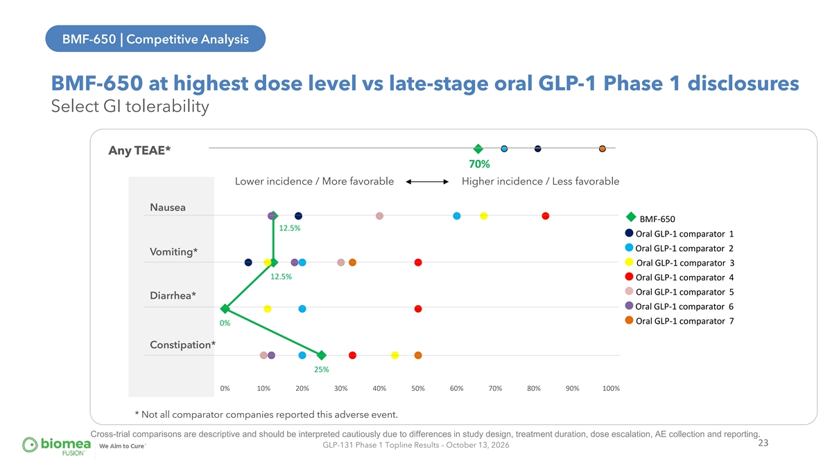
BMF-650 | Competitive Analysis BMF-650 at highest dose level vs late-stage oral GLP-1 Phase 1 disclosures Select GI tolerability Any TEAE* 70% Lower incidence / More favorable Higher incidence / Less favorable Nausea ◆ BMF-650 12.5% ● Oral GLP-1 comparator 1 ● Oral GLP-1 comparator 2 Vomiting* ● Oral GLP-1 comparator 3 12.5% ● Oral GLP-1 comparator 4 ● Oral GLP-1 comparator 5 Diarrhea* ● Oral GLP-1 comparator 6 ● Oral GLP-1 comparator 7 0% Constipation* 25% 0% 10% 20% 30% 40% 50% 60% 70% 80% 90% 100% * Not all comparator companies reported this adverse event. Cross-trial comparisons are descriptive and should be interpreted cautiously due to differences in study design, treatment duration, dose escalation, AE collection and reporting. 23 GLP-131 Phase 1 Topline Results – October 13, 2026

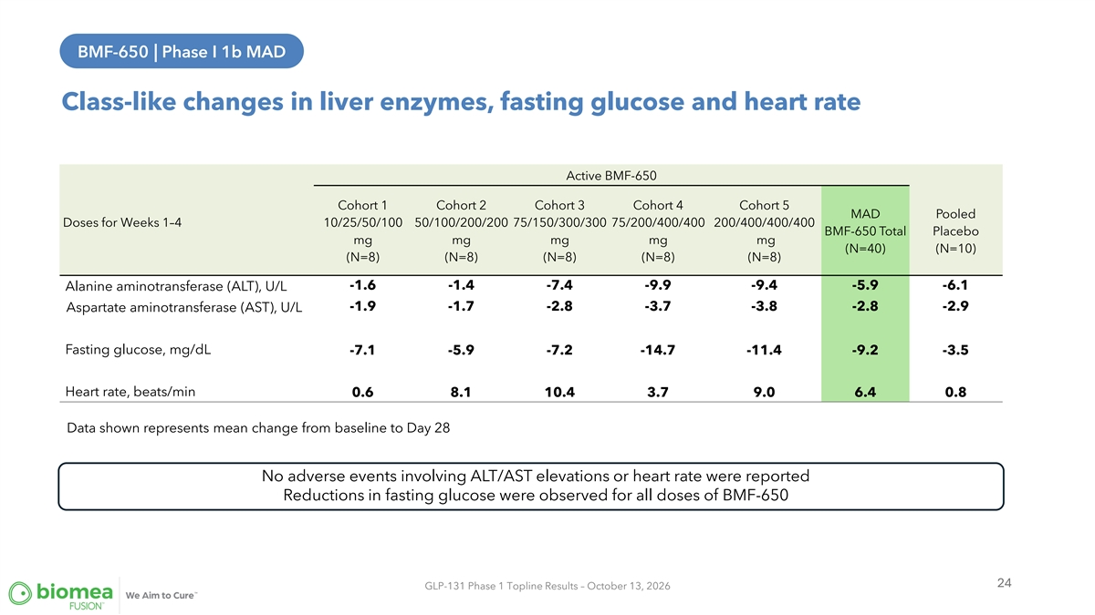
BMF-650 | Phase I 1b MAD Class-like changes in liver enzymes, fasting glucose and heart rate Active BMF-650 Cohort 1 Cohort 2 Cohort 3 Cohort 4 Cohort 5 MAD Pooled Doses for Weeks 1–4 10/25/50/100 50/100/200/200 75/150/300/300 75/200/400/400 200/400/400/400 BMF-650 Total Placebo mg mg mg mg mg (N=40) (N=10) (N=8) (N=8) (N=8) (N=8) (N=8) -1.6 -1.4 -7.4 -9.9 -9.4 -5.9 -6.1 Alanine aminotransferase (ALT), U/L -1.9 -1.7 -2.8 -3.7 -3.8 -2.8 -2.9 Aspartate aminotransferase (AST), U/L Fasting glucose, mg/dL -7.1 -5.9 -7.2 -14.7 -11.4 -9.2 -3.5 Heart rate, beats/min 0.6 8.1 10.4 3.7 9.0 6.4 0.8 Data shown represents mean change from baseline to Day 28 No adverse events involving ALT/AST elevations or heart rate were reported Reductions in fasting glucose were observed for all doses of BMF-650 24 GLP-131 Phase 1 Topline Results – October 13, 2026

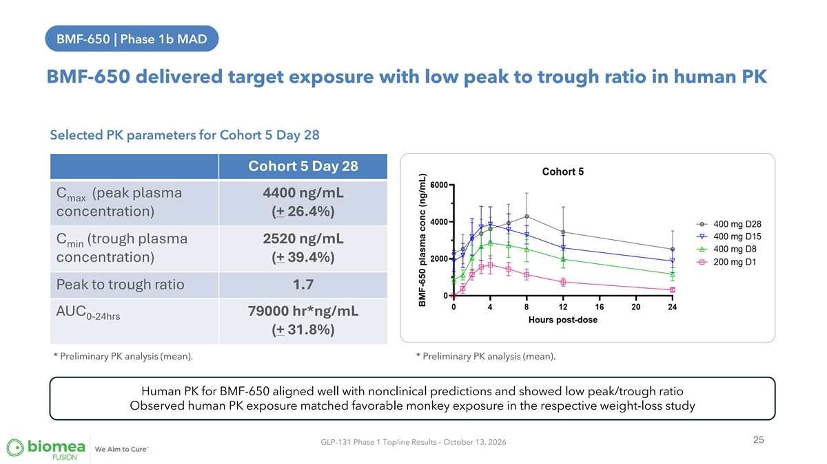
BMF-650 | Phase 1b MAD BMF-650 delivered target exposure with low peak to trough ratio in human PK Selected PK parameters for Cohort 5 Day 28 Cohort 5 Day 28 C (peak plasma 4400 ng/mL max concentration) (+ 26.4%) C (trough plasma 2520 ng/mL min concentration) (+ 39.4%) Peak to trough ratio 1.7 AUC 79000 hr*ng/mL 0-24hrs (+ 31.8%) * Preliminary PK analysis (mean). * Preliminary PK analysis (mean). Human PK for BMF-650 aligned well with nonclinical predictions and showed low peak/trough ratio Observed human PK exposure matched favorable monkey exposure in the respective weight-loss study 25 GLP-131 Phase 1 Topline Results – October 13, 2026

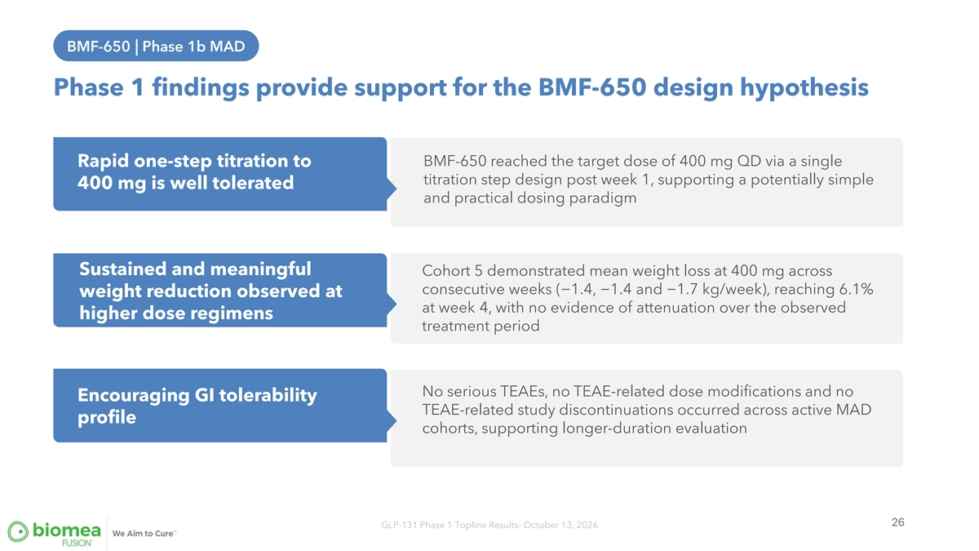
BMF-650 | Phase 1b MAD Phase 1 findings provide support for the BMF-650 design hypothesis BMF-650 reached the target dose of 400 mg QD via a single Rapid one-step titration to titration step design post week 1, supporting a potentially simple 400 mg is well tolerated and practical dosing paradigm Sustained and meaningful Cohort 5 demonstrated mean weight loss at 400 mg across consecutive weeks (−1.4, −1.4 and −1.7 kg/week), reaching 6.1% weight reduction observed at at week 4, with no evidence of attenuation over the observed higher dose regimens treatment period No serious TEAEs, no TEAE-related dose modifications and no Encouraging GI tolerability TEAE-related study discontinuations occurred across active MAD profile cohorts, supporting longer-duration evaluation 26 GLP-131 Phase 1 Topline Results- October 13, 2026

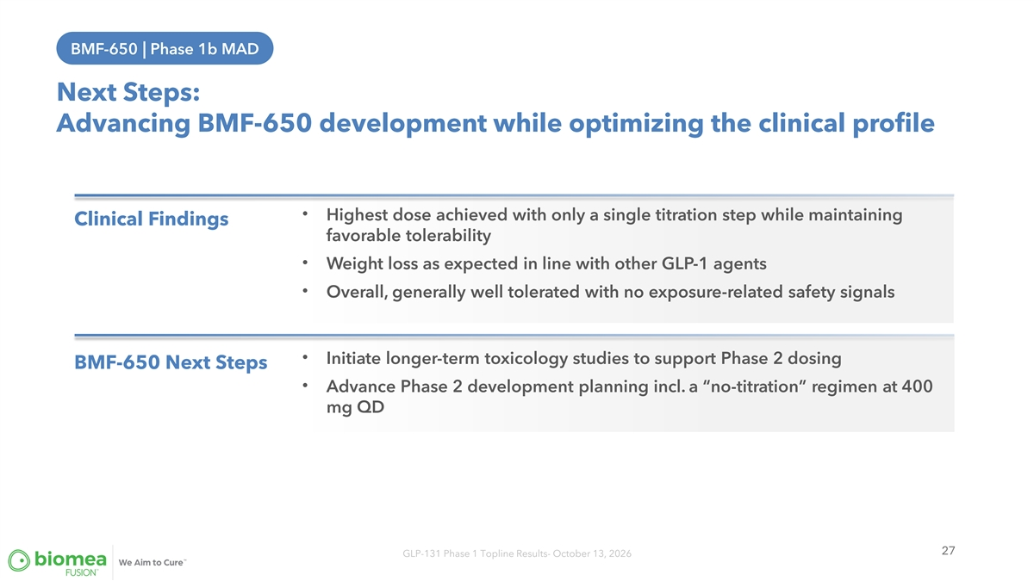
BMF-650 | Phase 1b MAD Next Steps: Advancing BMF-650 development while optimizing the clinical profile • Highest dose achieved with only a single titration step while maintaining Clinical Findings favorable tolerability • Weight loss as expected in line with other GLP-1 agents • Overall, generally well tolerated with no exposure-related safety signals • Initiate longer-term toxicology studies to support Phase 2 dosing BMF-650 Next Steps • Advance Phase 2 development planning incl. a “no-titration” regimen at 400 mg QD 27 GLP-131 Phase 1 Topline Results- October 13, 2026


Mick Hitchcock, PhD Interim Chief Executive Officer & Board Member, Biomea Fusion Executive Summary Dr. Juan Pablo Frias Chief Medical Officer of Biomea Fusion 28


Q & A Dr. Juan Pablo Frias Chief Medical Officer of Biomea Fusion 29
Exhibit 99.2


Biomea Fusion Announces Phase 1 Results for BMF-650, its Investigational
Next-Generation Oral Small Molecule GLP-1 Receptor Agonist

 |  |  | Mean weight reduction ranged from 1.5% to 3.2% at Day 29 across Cohorts 1-4, compared with 0.1% for pooled placebo.

 |  |  | No severe or serious TEAEs, no TEAE-related dose modifications, and no TEAE-related discontinuations among all BMF-650-treated MAD participants.

 |  |  | A rapid one-step titration to the target dose of 400 mg QD in Cohort 5 was equally well tolerated with all TEAEs being mild, with nausea and vomiting each reported in only 12.5% of participants, supporting further evaluation of “no titration” dosing for patients.

 |  |  | Company to host conference call on October 13 at 4:30 p.m. ET (1:30 p.m. PT).
SAN CARLOS, Calif., October 13, 2026 (GLOBE NEWSWIRE) — Biomea Fusion, Inc. (“Biomea” or the “Company”) (Nasdaq: BMEA), a clinical-stage biopharmaceutical company, today announced Phase 1 GLP-131 clinical trial results for BMF-650, its investigational oral small-molecule glucagon-like peptide-1 receptor agonist (“GLP-1 RA”), which demonstrated consistent weight reduction across five multiple ascending dose (“MAD”) cohorts over four weeks and encouraging tolerability even when reaching 400 mg QD in the highest dosing cohort after only a single one-week titration step. Together, these findings provide encouraging early evidence of BMF-650’s clinical activity, sustained weight-reduction trajectory, and, importantly, it’s tolerability.
“BMF-650 is the culmination of a program we initiated approximately four years ago, and these Phase 1 results provide important clinical validation of the work behind its design,” said Mick Hitchcock, Ph.D., Interim Chief Executive Officer and Board Member of Biomea Fusion. “We observed consistent weight reduction across multiple dose cohorts, encouraging tolerability and the ability to reach 400 mg after just one brief titration step. We believe these findings warrant further evaluation, including through potential collaborations. At the same time, our primary development focus remains firmly on menin inhibition with icovamenib in type 1 and type 2 diabetes, where we have several important clinical milestones ahead.”
The randomized, double-blind, placebo-controlled Phase 1 GLP-131 study evaluated safety and tolerability measures as co-primary endpoints and pharmacokinetics, pharmacodynamics and weight reduction in overweight or obese, otherwise healthy adults as key secondary endpoints. The study included a single ascending dose part followed by five MAD cohorts. In Cohorts 1-4, mean Day 29 weight reduction ranged from 1.5% to 3.2%, compared with 0.1% for pooled placebo from those cohorts. Across Cohorts 1-4, the mean weekly weight reduction at doses of 200 mg or higher once daily was approximately 0.97 kg. Additional data analysis remains ongoing, and we expect to present those results at a future medical meeting.

To ensure dosing compliance and better characterize the safety and tolerability profile of BMF-650, an additional fifth MAD cohort was conducted under confinement. Participants received 200 mg BMF-650 once daily for one week followed by 400 mg once daily for three weeks. At Day 29, mean weight reduction was 6.1% (6.2 kg), averaging approximately 1.55 kg per week, without observed attenuation during treatment. A similar weight reduction was observed by the two placebo patients. While all participants were provided 2,100 kcal/day, the 2 placebo participants consumed only approximately 33% of the presented food. As confinement appeared to have affected eating behavior for the Cohort 5 participants, we believe the results of Cohort 5 should be interpreted separately from the outpatient Cohorts 1-4.
Safety and Tolerability
Across the five active-dose MAD cohorts (n=40), all reported treatment-emergent adverse events (TEAEs) were mild or moderate. There were no severe or serious TEAEs, TEAE-related dose modifications, or TEAE-related study discontinuations. In the highest dosing group, Cohort 5, nausea and vomiting were each reported in one of eight BMF-650-dosed participants (12.5%), constipation in two (25%) and diarrhea in none (0%); these gastrointestinal (“GI”) events were all Grade 1. Across all active MAD cohorts, nausea occurred in 17.5%, vomiting in 7.5%, constipation in 10%, and diarrhea in 5% of participants. No adverse events of increased Alanine Aminotransferase (“ALT”)/ Aspartate Aminotransferase (“AST”) were reported. These findings are preliminary and reflect outcomes from four weeks of treatment.
Pharmacokinetics and Simple Titration
BMF-650 was designed with a medicinal chemistry strategy to separate GI adverse events from weight loss objectives. BMF-650 in Cohort 5 demonstrated sustained systemic exposures supporting once-daily oral administration with a low peak to trough ratio. Participants who advanced from 200 mg once daily to 400 mg once daily after one week remained at 400 mg for the subsequent three weeks (Cohort 5) and demonstrated similar GI tolerability as the other patients who underwent slower titration. We believe these data may provide sufficient support to test for a potential ‘no titration’ regimen. Further longer-duration studies and additional clinical data will be needed to fully characterize the optimal patient dosing regimen for BMF-650.
“Our objective in designing BMF-650 was not to maximize weight loss compared to other oral GLP-1s, but rather we specifically designed the molecule for less acute GLP-1 receptor agonism in the GI tract, with the goal of improving GI tolerability while maintaining weight loss consistent with industry standards weight loss. Our goal was to eliminate titration steps which can take 5 months or more with other GLP-1s and are typically required to avoid over-agonism. BMF-650 was designed to ultimately increase persistence with chronic therapy,” said Thorsten Kirschberg, Ph.D., Executive Vice President of Research at Biomea Fusion and program lead for BMF-650. “BMF-650 demonstrated good oral absorption in this study with consistent and sustained systemic exposure. We believe these Phase 1 results provide initial clinical evidence supporting our design strategy, with meaningful weight reduction, a well- tolerated safety profile, and rapid one-step titration to the 400 mg target dose without increasing local GI agonism and side effects.”
BMF-650 Development Considerations
After finalizing data collection from the Phase 1b clinical trial, additional clinical development of BMF-650 will require longer-term toxicology studies. Biomea intends to continue that work while positioning the program for a strategic partnership, which could include a licensing arrangement for late-stage development and commercialization.

Conference Call and Webcast Details
Biomea’s management will host a conference call on October 13, 2026, at 4:30 p.m. ET (1:30 p.m. PT). The live webcast will be available under the Investors and Media section of the Company’s website at https://investors.biomeafusion.com/news-events/events. A replay of the webcast will be archived on Biomea’s website following the event.
About the Phase 1 Study
The GLP-131 Phase 1 (NCT07223216) study is a randomized, double-blind, placebo-controlled, single and MAD study evaluating safety, tolerability, pharmacokinetics, pharmacodynamics and effects on body weight of BMF-650 in otherwise healthy overweight or obese adult participants. The study includes a single ascending dose portion and five MAD cohorts. The fifth MAD cohort was added to evaluate a rapid one-step titration regimen, with participants receiving 200 mg once daily for one week followed by 400 mg once daily for three weeks.
About Biomea Fusion
Biomea Fusion is a clinical-stage biopharmaceutical company advancing oral small molecule therapies, icovamenib and BMF-650, for diabetes and obesity. These programs target metabolic disorders, a global health challenge affecting nearly half of Americans and one-fifth of the world’s population. Biomea’s mission is to deliver transformative treatments that restore health for patients living with diabetes, obesity and related conditions. We aim to cure.
Visit us at biomeafusion.com and follow us on LinkedIn, Twitter and Facebook.
Forward-Looking Statements
Statements we make in this press release may include statements which are not historical facts and are considered forward-looking statements within the meaning of Section 27A of the Securities Act of 1933, as amended (the “Securities Act”), and Section 21E of the Securities Exchange Act of 1934, as amended (the “Exchange Act”). These statements may be identified by words such as “aims,” “anticipates,” “believes,” “could,” “estimates,” “expects,” “forecasts,” “goal,” “intends,” “may,” “plans,” “possible,” “potential,” “seeks,” “will,” and variations of these words or similar expressions that are intended to identify forward-looking statements. Any such statements in this press release that are not statements of historical fact, including statements regarding the clinical and therapeutic potential of our product candidates and development programs, including icovamenib and BMF-650; the potential of icovamenib as a treatment for T1D and T2D; our research, development and regulatory plans; the timing of patient enrollment and dosing completion, and progress and availability of data from our clinical trials, including for the COVALENT-211 and COVALENT-212 Phase 2 trials; and our ongoing Phase 1 trial evaluating BMF-650; the potential clinical profile of BMF-650 and its development as a next-generation oral GLP-1 RA for obesity and metabolic disease; the mechanism of action of our product candidates and development programs; and the results and timing of such events may be deemed to be forward-looking statements. We intend these forward-looking statements to be covered by the safe harbor provisions for forward-looking statements contained in Section 27A of the Securities Act and Section 21E of the Exchange Act and are making this statement for purposes of complying with those safe harbor provisions. Any forward-looking statements in this press release are based on our current expectations, estimates and

projections only as of the date of this release and are subject to a number of risks and uncertainties that could cause actual results to differ materially and adversely from those set forth in or implied by such forward-looking statements, including the risk that preliminary or interim results of nonclinical studies or clinical trials may not be predictive of future or final results in connection with future clinical trials and the risk that we may encounter delays or adverse outcomes in regulatory interactions, nonclinical or clinical development, patient enrollment and in the initiation, conduct and completion of our ongoing and planned clinical trials and other research and development activities. These risks concerning Biomea Fusion’s business and operations are described in additional detail in its periodic filings with the U.S. Securities and Exchange Commission (“SEC”), including its most recent periodic report filed with the SEC and subsequent filings thereafter. Biomea Fusion explicitly disclaims any obligation to update any forward-looking statements except to the extent required by law.
Contact:
Meichiel Jennifer Weiss
Senior Director of Investor Relations and Corporate Development
ir@biomeafusion.com

